

Date:
Sultan Yasir Alasami 2339663
Abdulaziz Sattam Alobaili 2446346
Faisal Hussein Alghamdi 2337220

  - Prepared by: ID:

CPU Scheduling Simulator – Dynamic & Static Round Robin
College: FCIT
Course: CPCS361 Section CS2
GROUP 3

Introduction:
CPU scheduling is one of the essential components of an operating system, as it determines how processes are assigned to the processor and how system resources are managed. Efficient scheduling improves system performance, reduces waiting time, and ensures fairness among processes.
In this project, a CPU Scheduling Simulator was developed to model the behavior of the Dynamic Round Robin (DRR) scheduling algorithm. The simulator manages memory allocation, device allocation, hold queues, the ready queue, and CPU execution.
The goal of the project is to understand how DRR performs under different system configurations, and how factors such as memory availability, process arrival time, and burst time influence the scheduler’s behavior.

Objectives

- To implement a CPU scheduling simulator that supports the Dynamic Round Robin algorithm.
- To simulate process arrivals, memory allocation, and device allocation within system constraints.
- To observe how system parameters affect scheduling decisions and process execution.
- To analyze and compare system behaviour under different configurations.
- To generate snapshots of system status at specific times, including ready queues, hold queues, and finished jobs.

System Specifications:
The following configuration was used for the development and testing of the CPU Scheduling Simulator:
Development Environment:
- Compiler: Java Development Kit (JDK) 24
- Operating System: Windows 11 Home, Version 24H2
- Hardware: AMD Radeon 4800H, 16GB RAM

System Design

The simulator consists of several main components that work together to model the operating system environment:

3.1 Process Structure
Each process contains:
- Process ID
- Arrival time
- Burst time
- Remaining time
- Memory and device requirements
- Priority level (for HQ1 and HQ2)
- Start time and finish time

3.2 Queues and Resource Management
The system includes:
- Ready Queue
- Hold Queue 1 (priority-based)
- Hold Queue 2 (FIFO)
- Memory manager
- Device manager
Processes are admitted into the system only if memory and device requirements are satisfied.

3.3 Scheduler
The Dynamic Round Robin scheduler computes the time quantum based on the average remaining time of all processes currently in the ready queue.
If one process remains, its entire remaining burst time becomes the time quantum.

3.4 Simulation Controller
The controller reads the input file, processes commands, manages events (internal and external), updates time, and prints system snapshots.

Source Code:

SimulationController.java
package ProjectOS;
import java.io.*;
import java.util.ArrayList;
public class SimulationController {
private static final int TEAM_NO = 3;
private static final int STATIC_QUANTUM = 10 + TEAM_NO;
PrintWriter pn = new PrintWriter("output.txt");
double currentTime = 0.0;
final File inputFile = new File("inputDRR_simple1.txt");
final String defaultSchedType = inputFile.getName().toLowerCase().contains("inputdrr")? "dynamic" : "static";
OtherKerServices oks;
PrManager pm;
public SimulationController() throws FileNotFoundException {
}
void sysGen(double start, long mem, int devs, String schedType){
oks = new OtherKerServices(mem, devs);
Scheduler sch;
if("static".equalsIgnoreCase(schedType)){
sch = new SRoundRobinScheduler(STATIC_QUANTUM);
}else{
sch = new DRoundRobinScheduler();
}
pm = new PrManager(oks, sch);
currentTime = start;
String schName = (sch instanceof DRoundRobinScheduler) ? "DynamicRR" : "StaticRR";
pn.printf("CONFIG at %s: mem=%d devices=%d scheduler=%s%n%n",
fmtTime(start), mem, devs, schName);
}
double parseTime(String line){
String[] sp = line.trim().split(" ");
return Double.parseDouble(sp[1]);
}
void parseCmd(String line2){
String[] sp = line2.trim().split(" ");
switch (sp[0]) {
case "C" -> {
double start = Double.parseDouble(sp[1]);
long M = Long.parseLong(sp[2].substring(2));
int S = Integer.parseInt(sp[3].substring(2));
String schedType = defaultSchedType;
sysGen(start, M, S, schedType);
}
case "A" -> {
double at = Double.parseDouble(sp[1]);
long J = Long.parseLong(sp[2].substring(2));
long M = Long.parseLong(sp[3].substring(2));
long S = Long.parseLong(sp[4].substring(2));
double R = Double.parseDouble(sp[5].substring(2));
int P = Integer.parseInt(sp[6].substring(2));
pm.procArrivingRoutine(J, at, R, P, M, S);
}
case "D" -> {
displayFinalStatistics();
}
}
}
public void main(String[] args) throws Exception{
try(BufferedReader br = new BufferedReader(new FileReader(inputFile))){
String command = null;
String line = br.readLine();
while(line != null && line.trim().isEmpty()){
line = br.readLine();
}
if(line != null){
command = line.trim();
}
while(true){
double nextIntTime = (pm == null) ? Double.POSITIVE_INFINITY : pm.getNextDecisionTime();
boolean noMoreExt = (command == null);
boolean noMoreInt = (pm == null) || !pm.hasWork();
if(noMoreExt && noMoreInt) break;
double nextExtTime = Double.POSITIVE_INFINITY;
if(!noMoreExt){
nextExtTime = parseTime(command);
}
double oldTime = currentTime;
if(nextIntTime <= nextExtTime){
currentTime = nextIntTime;
pm.executeInternalEvent(currentTime);
}else{
currentTime = nextExtTime;
while(command != null &&
Math.abs(parseTime(command) - currentTime) < 1e-9){
parseCmd(command);
command = br.readLine();
while(command != null && command.trim().isEmpty()){
command = br.readLine();
}
if(command == null) break;
}
}
double duration = currentTime - oldTime;
pm.cpuTimeAdvance(duration);
pm.dispatch(currentTime);
}
}
pn.println();
pn.println("--- Simulation finished at time " + currentTime + " ---");
pn.println();
pn.flush();
}
String fmtTime(double t){
return String.format("%.2f", t);
}
public void displayFinalStatistics(){
String line = "-------------------------------------------------------";
pn.println(line);
pn.println("System Status: ");
pn.println(line);
pn.printf(" Time: %s%n", fmtTime(currentTime));
pn.printf(" Total Memory: %d%n", oks.getMemorySize());
pn.printf(" Avail. Memory: %d%n", oks.getAvailMem());
pn.printf(" Total Devices: %d%n", oks.getNoDevs());
pn.printf("Avail. Devices: %d%n", oks.getAvailDevs());
pn.println();
pn.println("Jobs in Ready List ");
pn.println("--------------------------------------------------------");
if (pm.readyQ.isEmpty()) {
pn.println(" EMPTY");
} else {
for (Process p : pm.readyQ.asList()) {
pn.printf("Job ID %d , %.2f Cycles left to completion.%n",
p.getPID(), p.getRemaining());
}
}
pn.println();
pn.println("Jobs in Long Job List ");
pn.println("--------------------------------------------------------");
pn.println(" EMPTY");
pn.println();
pn.println("Jobs in Hold List 1 ");
pn.println("--------------------------------------------------------");
if (pm.HQ1.isEmpty()) {
pn.println(" EMPTY");
} else {
ArrayList<Process> tmp = new ArrayList<>(pm.HQ1.asList());
for (Process p : tmp) {
pn.printf("Job ID %d , %.2f Cycles left to completion.%n",
p.getPID(), p.getRemaining());
}
}
pn.println();
pn.println("Jobs in Hold List 2 ");
pn.println("--------------------------------------------------------");
if (pm.HQ2.isEmpty()) {
pn.println(" EMPTY");
} else {
for (Process p : pm.HQ2.asList()) {
pn.printf("Job ID %d , %.2f Cycles left to completion.%n",
p.getPID(), p.getRemaining());
}
}
pn.println();
pn.println();
pn.println("Finished Jobs (detailed) ");
pn.println("--------------------------------------------------------");
pn.println(" Job ArrivalTime CompleteTime TurnaroundTime WaitingTime");
pn.println("------------------------------------------------------------------------");
if (pm.getProcesstable().length == 0)
pn.println(" EMPTY\n\n\n");
else {
for (int i = 0; i < pm.getSize() - 1; i++) {
int minIndex = i;
for (int j = i + 1; j < pm.getSize(); j++) {
if (pm.getProcesstable()[j].getPID() < pm.getProcesstable()[minIndex].getPID()) {
minIndex = j;
}
}
Process temp = pm.getProcesstable()[i];
pm.getProcesstable()[i] = pm.getProcesstable()[minIndex];
pm.getProcesstable()[minIndex] = temp;
}
}
for (Process p : pm.getProcesstable()) {
if (p == null) break;
double tat = p.getFinishTime() - p.getArrivalTime();
double waiting = tat - p.getBurstTime();
pn.printf(" %-6d %-15s %-17s %-18.2f %-15.2f%n",
p.getPID(),
fmtTime(p.getArrivalTime()),
fmtTime(p.getFinishTime()),
tat,
waiting);
}
pn.printf("Total Finished Jobs: %d%n", pm.getSize());
pn.println("\n\n");
pn.flush();
}
}

PrManager.java
package ProjectOS;
public class PrManager {
final Queue readyQ = new Queue();
final Queue HQ2 = new Queue();
SortedQueue HQ1 = new SortedQueue();
final Scheduler scheduler1;
final OtherKerServices oks;
final private Process[] processtable = new Process[100];
private int size = 0;
Process current = null;
double currentSliceEndTime = Double.POSITIVE_INFINITY;
double currentSliceRun = 0.0;
private double internalClock = 0.0;
double SR = 0.0;
double AR = 0.0;
PrManager(OtherKerServices oks, Scheduler sch){
this.oks = oks;
this.scheduler1 = sch;
}
boolean hasWork(){
return current != null ||
!readyQ.isEmpty() ||
!HQ1.isEmpty() ||
!HQ2.isEmpty();
}
void cpuTimeAdvance(double duration){
if (duration > 0) {
internalClock += duration;
}
}
private void updateSR_AR(){
SR = 0.0;
for (Process p : readyQ.asList()) {
SR += p.getRemaining();
}
if (readyQ.size() > 0) {
AR = SR / readyQ.size();
} else {
AR = 0.0;
}
}
void procArrivingRoutine(long J, double at, double R, int P, long M, long S){
Process p = new Process(J, at, R, P, M, S);
if(p.getMemoryReq() > oks.getMemorySize() || p.getDevReq() > oks.getNoDevs()) return;
processtable[size++] = p;
boolean mem = oks.allocateMemory(p);
boolean dev = oks.reserveDevices(p);
if(!(mem && dev)){
if(mem) oks.deallocateMemory(p);
if(dev) oks.releaseDevices(p);
if(p.getPriority() == 1){
HQ1.enqueue(p);
p.setState(2);
} else {
HQ2.enqueue(p);
p.setState(2);
}
return;
}
readyQ.enqueue(p);
p.setState(1);
updateSR_AR();
}
void admitFromHolds(){
boolean changed;
do{
changed = false;
if(!HQ1.isEmpty()){
boolean finish = false;
while(!finish){
Process j = HQ1.peek();
if(oks.allocateMemory(j) && oks.reserveDevices(j)) {
HQ1.dequeue();
readyQ.enqueue(j);
j.setState(1);
}
else finish = true;
changed = true;
}
}
if(!HQ2.isEmpty()){
boolean finish2 = false;
while(!finish2) {
Process j2 = HQ2.asList().get(0);
if (oks.allocateMemory(j2) && oks.reserveDevices(j2)) {
HQ2.dequeue();
readyQ.enqueue(j2);
j2.setState(2);
}
else finish2 = true;
}
changed = true;
}
}while(changed);
updateSR_AR();
}
void dispatch(double now){
if(current != null) return;
if(readyQ.isEmpty()) return;
Process selected = scheduler1.selectNextProcess(readyQ);
current = selected;
if(current == null)
return;
current.setState(3);
if(current.getStartTime() == 0) current.setStartTime(now);
if(scheduler1 instanceof DRoundRobinScheduler){
if(readyQ.size() == 0){
((DRoundRobinScheduler) scheduler1).setTimeQunt(current.getRemaining());
}else{
double total = current.getRemaining();
int count = 1;
for (Process p : readyQ.asList()) {
total += p.getRemaining();
count++;
}
((DRoundRobinScheduler) scheduler1).setTimeQunt(Math.round(total / count));
}
if (((DRoundRobinScheduler) scheduler1).getTimeQunt() < 1.0) {
((DRoundRobinScheduler) scheduler1).setTimeQunt(1.0);
}
} else {
}
if(scheduler1 instanceof DRoundRobinScheduler)
currentSliceRun = Math.min(((DRoundRobinScheduler) scheduler1).getTimeQunt(), current.getRemaining());
else currentSliceRun = Math.min(((SRoundRobinScheduler) scheduler1).getTimeQuantum(), current.getRemaining());
currentSliceEndTime = now + currentSliceRun;
}
double getNextDecisionTime(){
return current == null ? Double.POSITIVE_INFINITY : currentSliceEndTime;
}
void executeInternalEvent(double now){
if(current == null) return;
current.setRemaining(current.getRemaining() - currentSliceRun);
if(current.getRemaining() == 0){
current.setState(4);
current.setFinishTime(now);
oks.deallocateMemory(current);
oks.releaseDevices(current);
current = null;
admitFromHolds();
}else{
readyQ.enqueue(current);
current.setState(1);
current = null;
}
updateSR_AR();
if(current == null){
currentSliceEndTime = Double.POSITIVE_INFINITY;
currentSliceRun = 0.0;
}
}
public Process[] getProcesstable() {
return processtable;
}
public int getSize() {
return size;
}
public long getRunningProcessId(){
return current.getPID();
}
}

OtherKerServices.java
package ProjectOS;
public class OtherKerServices {
private long memorySize;
private int noDevs;
private long availMem;
private int availDevs;
OtherKerServices(long mem, int devs){
memorySize = mem;
noDevs = devs;
availMem = mem;
availDevs = devs;
}
boolean allocateMemory(Process p){
if(p.getMemoryReq() > memorySize) return false;
if(p.getMemoryReq() <= availMem){
availMem -= p.getMemoryReq();
return true;
}
return false;
}
void deallocateMemory(Process p){
availMem += p.getMemoryReq();
}
boolean reserveDevices(Process p){
if(p.getDevReq() > noDevs) return false;
if(p.getDevReq() <= availDevs){
availDevs -= p.getDevReq();
return true;
}
return false;
}
void releaseDevices(Process p){
availDevs += p.getDevReq();
}
public long getMemorySize() {
return memorySize;
}
public int getNoDevs() {
return noDevs;
}
public long getAvailMem() {
return availMem;
}
public int getAvailDevs() {
return availDevs;
}
}

Process.java
package ProjectOS;
public class Process {
private long PID, memoryReq, devReq;
private int priority;
private double arrivalTime;
private double burstTime;
private double remaining;
private double startTime = 0;
private double finishTime = 0;
private int state;
Process(long pid, double at, double bt, int pr, long mem, long dev){
PID = pid;
arrivalTime = at;
burstTime = bt;
remaining = bt;
priority = pr;
memoryReq = mem;
devReq = dev;
}
public double getStartTime() {
return startTime;
}
public void setStartTime(double startTime) {
this.startTime = startTime;
}
public double getFinishTime() {
return finishTime;
}
public void setFinishTime(double finishTime) {
this.finishTime = finishTime;
}
public int getState() {
return state;
}
public void setState(int state) {
this.state = state;
}
public long getPID() {
return PID;
}
public long getMemoryReq() {
return memoryReq;
}
public long getDevReq() {
return devReq;
}
public int getPriority() {
return priority;
}
public double getArrivalTime() {
return arrivalTime;
}
public double getBurstTime() {
return burstTime;
}
public double getRemaining() {
return remaining;
}
public void setRemaining(double remaining) {
this.remaining = remaining;
}
}

Queue.java
package ProjectOS;
import java.util.LinkedList;
public class Queue {
private LinkedList<Process> q = new LinkedList<>();
private String schType = "FIFO";
public void enqueue(Process p) {
q.addLast(p);
}
public Process dequeue() {
return q.pollFirst();
}
public boolean isEmpty() {
return q.isEmpty();
}
public int size() {
return q.size();
}
public LinkedList<Process> asList() {
return new LinkedList<>(q);
}
}

SortedQueue.java
package ProjectOS;
import java.util.LinkedList;
public class SortedQueue {
private LinkedList<Process> q = new LinkedList<>();
private String SchType = "memory and noDevs priority";
public void enqueue(Process p) {
if (q.isEmpty()) {
q.add(p);
return;
}
int i = 0;
while (i < q.size() && q.get(i).getMemoryReq() <= p.getMemoryReq()) {
i++;
}
q.add(i, p);
}
public Process dequeue() {
return q.pollFirst();
}
public boolean isEmpty() {
return q.isEmpty();
}
public int size() {
return q.size();
}
public LinkedList<Process> asList() {
return new LinkedList<>(q);
}
public Process peek() {
return q.peekFirst();
}
}

Scheduler.java
package ProjectOS;
abstract class Scheduler {
abstract Process selectNextProcess(Queue readyQ);
}

SRoundRobinScheduler.java
package ProjectOS;
public class SRoundRobinScheduler extends Scheduler {
final private double timeQuantum;
SRoundRobinScheduler(double q){ timeQuantum = q; }
@Override
Process selectNextProcess(Queue readyQ){
return readyQ.dequeue();
}
public double getTimeQuantum() {
return timeQuantum;
}
}

DRoundRobinScheduler.java
package ProjectOS;
public class DRoundRobinScheduler extends Scheduler {
private double timeQunt;
@Override
Process selectNextProcess(Queue readyQ){
return readyQ.dequeue();
}
public double getTimeQunt() {
return timeQunt;
}
public void setTimeQunt(double timeQunt) {
this.timeQunt = timeQunt;
}
}

4. Experiments and Results

4.1 Input Data
Two different input files were used to evaluate the CPU Scheduling Simulator.
The first file tests Dynamic Round Robin (DRR) scheduling, while the second file tests Static Round Robin (SRR) scheduling.
Each file contains system configuration commands, job arrival events, and display commands.

4.1.1 Dynamic Round Robin Input
The following input file was used to test the dynamic time quantum calculation:
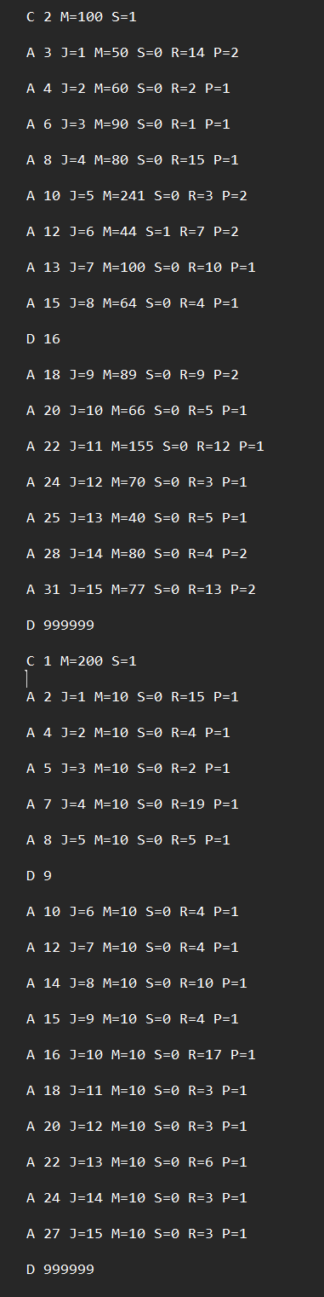

4.1.2 Static Round Robin Input
The following input file was used to test the fixed time quantum used in Static RR scheduling:

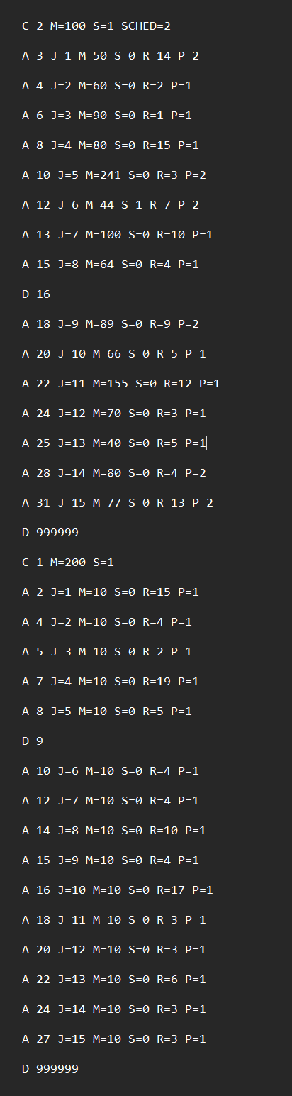

4.2 Output Results
This section presents the simulator output for both input files.
The output includes system snapshots at the requested times and the final table of completed jobs.

4.2.1 Dynamic Round Robin Output

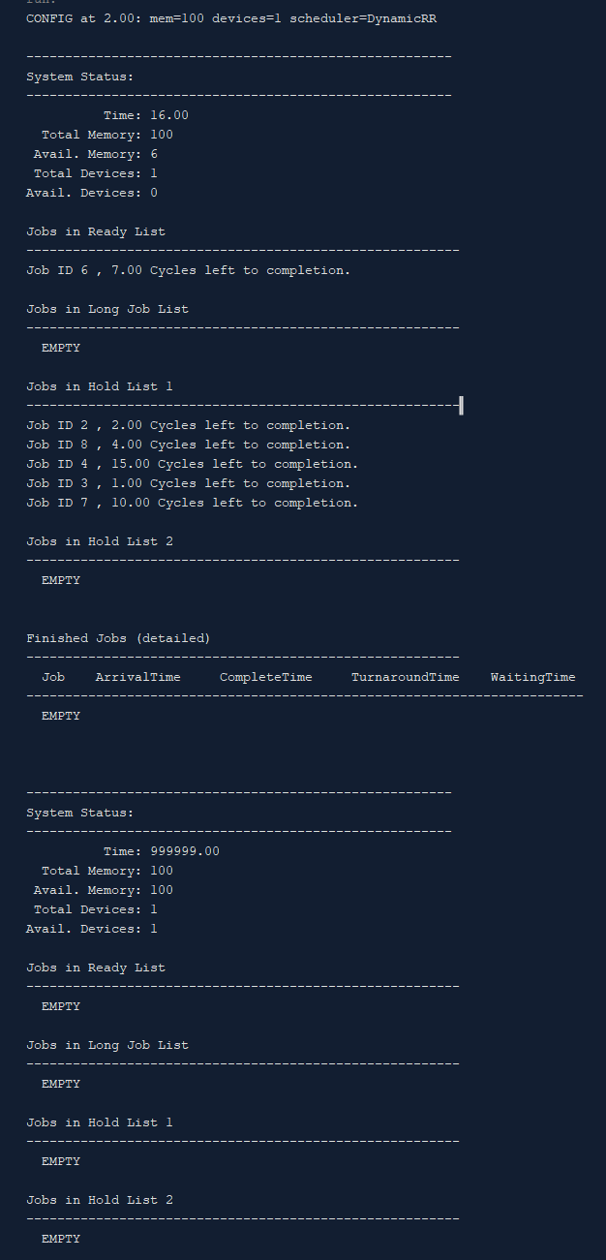

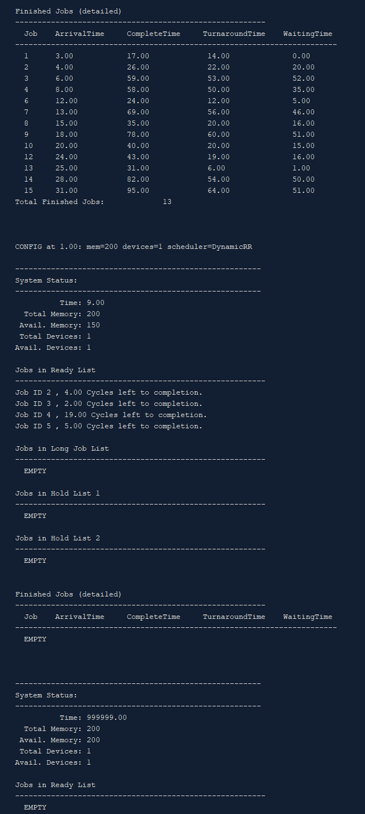

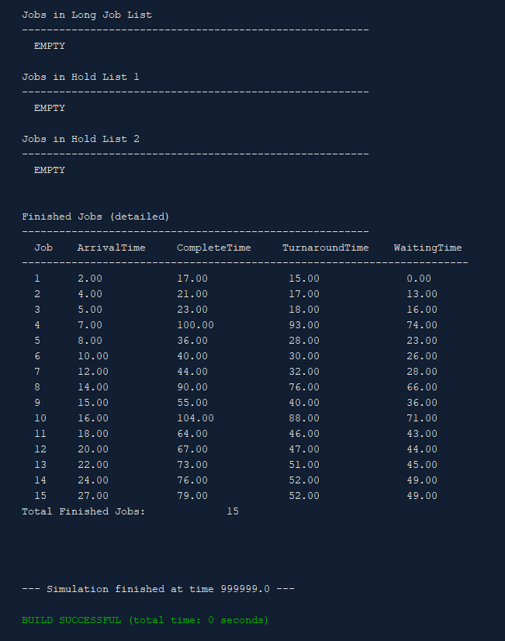

4.2.2 Static Round Robin Output

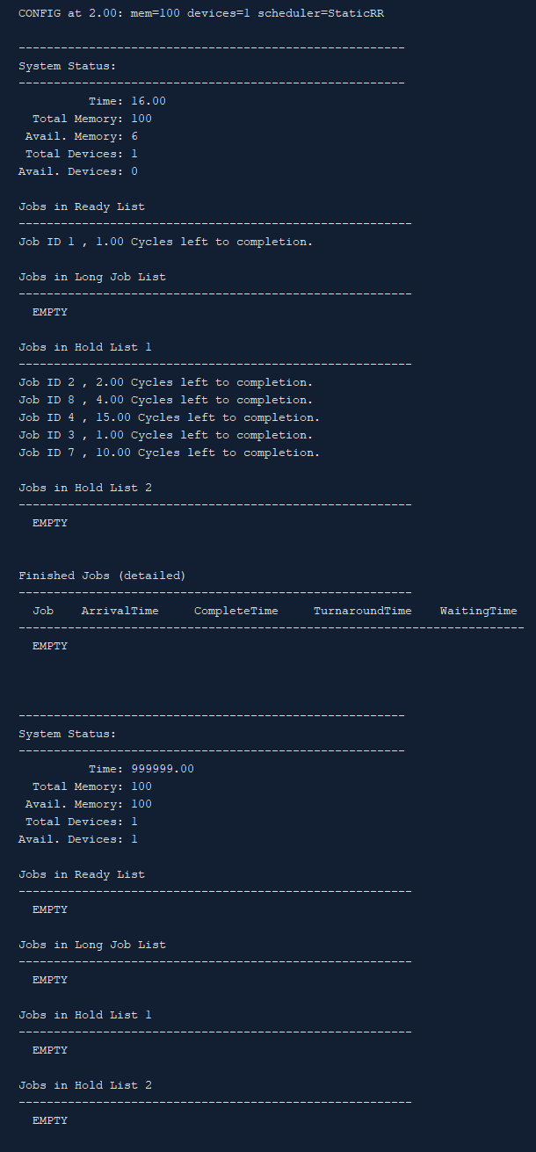

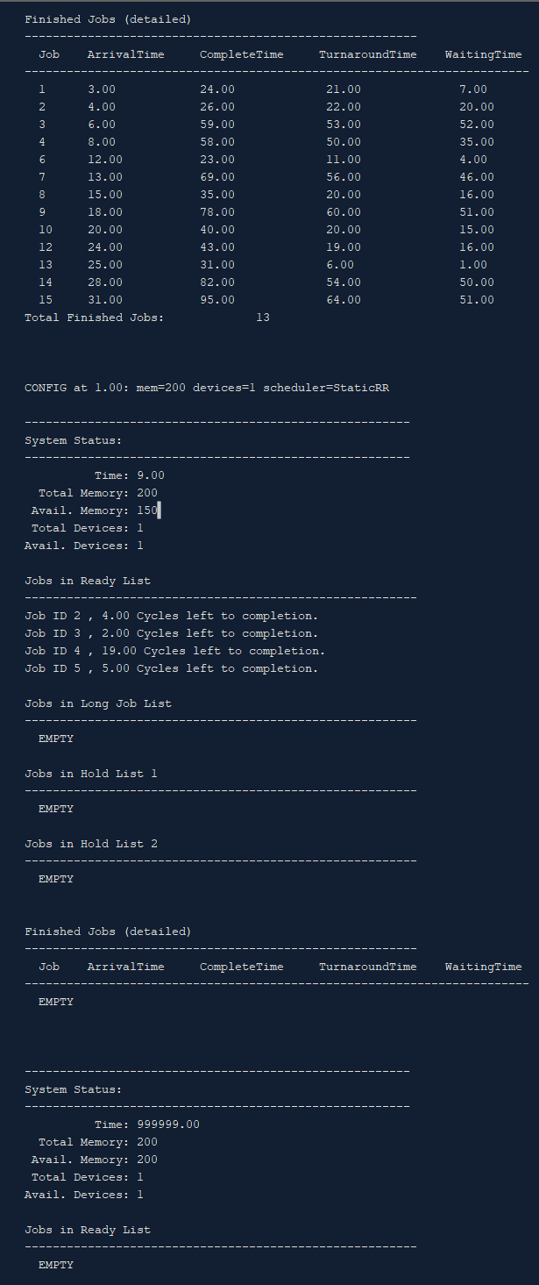

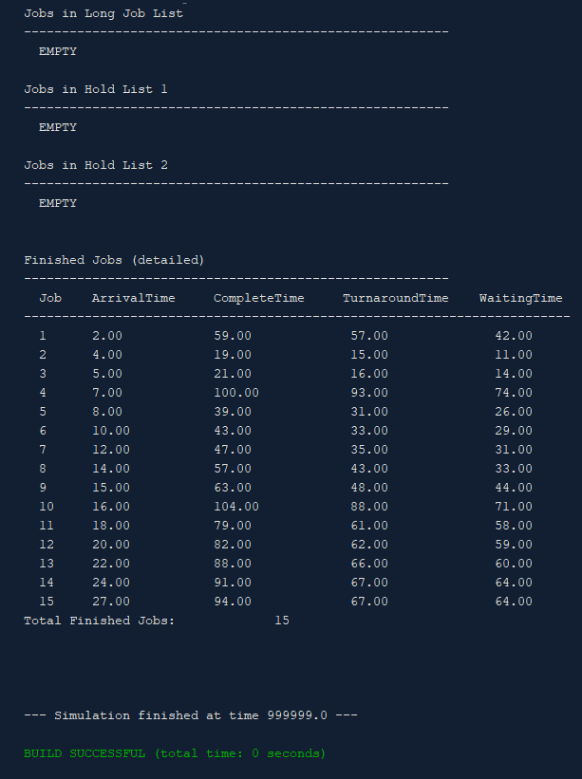

4.3 Analysis For Test Cases
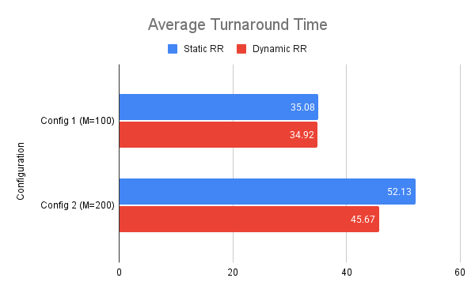

This chart shows that the Dynamic RR scheduler consistently resulted in a lower (better) average turnaround time for both configurations.
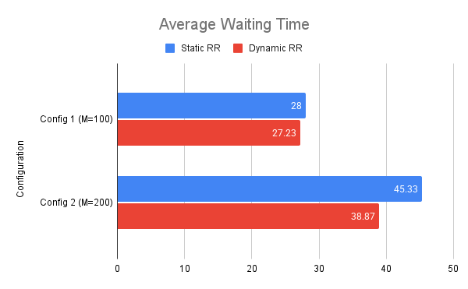
This chart shows that the Dynamic RR scheduler also achieved a lower (better) average waiting time in both test scenarios.
The results from both data tables and graphs clearly indicate that the Dynamic Round Robin (DRR) scheduler outperformed the Static Round Robin (SRR) scheduler in both test environments.
- In Config 1 (M=100), DRR was marginally faster, improving Turnaround Time by 0.16ms and Waiting Time by 0.77ms.
- In Config 2 (M=200), DRR showed significant improvement, being 12.4% faster in Turnaround Time and 14.2% faster in Waiting Time.
The reason for this improved performance lies in the DRR's adaptability. The Static RR scheduler was locked into a large, fixed quantum. This is inefficient for handling short jobs, as they are forced to wait for a full quantum to expire even if they only need 1 or 2 cycles.
The Dynamic RR scheduler, by calculating the quantum based on the average remaining burst time (AR), can adapt. When a mix of short and long jobs is in the ready queue, the AR will be lower than SRR's fixed quantum. This results in shorter quanta, allowing short jobs to be processed and completed more quickly, which in turn lowers the overall system average for both waiting and turnaround times.
To further evaluate the efficiency of the Dynamic Round Robin algorithm, two additional experiments were conducted to test scalability and specific edge cases.
Setup: A custom input file of 100 jobs where burst times ranging from 2ms to 28ms, to simulate a heavy, somewhat uniform workload
Metric | Static RR (SRR) | Dynamic RR (DRR) | Difference
Avg. Turnaround Time | 375.12 | 380.98 | ~1.5% (SRR Better)
Avg. Waiting Time | 365.27 | 371.13 | ~1.6% (SRR Better)

Interestingly, this stress test revealed a scenario where Static RR performed marginally better.
- The job mix consisted of many “medium-length” jobs
- The fixed quantum of 13 was well suited for this specific distribution, allowing many jobs to finish in just 1 or 2 turns.
- The Dynamic scheduler likely calculated a smaller average quantum (due to the presence of very short jobs). This caused medium jobs to be sliced more frequently than necessary (e.g., taking 3 turns instead of 2), slightly increasing their time in the system.
This highlights that while DRR is generally superior for responsiveness (waiting time), a well-tuned Static quantum can still be highly efficient for uniform, CPU-bound workloads.
We also conducted another test where it tests how the schedulers handle a specific mix designed to induce the "Convoy Effect", where many short processes are stuck waiting behind a few CPU intensive processes. Setup: An input of 50 jobs total, consisting of 10 Long jobs (Burst Time = 100) intermixed with 40 Short jobs (Burst Time = 2). This simulates a scenario where interactive or I/O-bound tasks are blocked by heavy computational tasks.
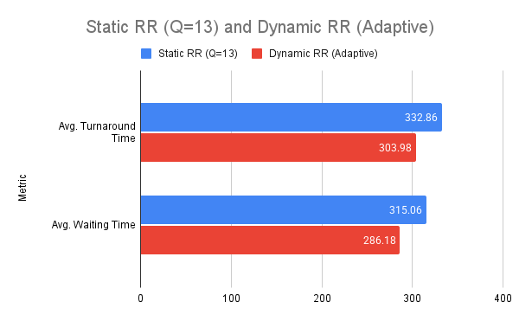

With a large fixed quantum of 13, short jobs that require only 2 ms were frequently forced to wait for long jobs to consume full time slices, this inflated the waiting time for 80% of the processes.
The reason why DRR succeeds here is due to the scheduler detecting the lower average burst time of the waiting short jobs and lowered the time quantum accordingly. This allowed the short jobs to skip ahead and finish quickly, drastically reducing the system-wide average waiting time by over 9%. This proves DRR is superior for preventing process starvation in mixed workloads.
Conclusion
The CPU Scheduling Simulator successfully demonstrates the operation of the Dynamic Round Robin scheduling algorithm under different conditions.
The results show that DRR is suitable for systems with many short processes, as it offers fairness and responsiveness. However, long processes experience longer waiting times, especially when mixed with many short jobs.
The simulator also highlights the strong effect of resource availability, particularly memory, on process admission and scheduling flow.
This project provides practical insight into CPU scheduling mechanisms, resource management, queue handling, and system-level simulation.

